

**Green University of Bangladesh**

**Department of Computer Science and Engineering (CSE)**

**Faculty of Sciences and Engineering**

**Semester: (Fall, Year: 2024), B.Sc. in CSE (Day)**

**Lab Report NO: 02**

**Course Title: Data Structure Lab**

**Course Code: CSE 206**

**Section: D8**

**Lab Experiment Name:** Basic operations of one-dimensional and two-dimensional array

**Student Details**

|  |  |  |
| --- | --- | --- |
| **Name** | | **ID** |
| **1.** | Ashab Uddin | 232002274 |

**Lab Date : 11/09/24**

**Submission Date : 20/09/24**

**Course Teacher’s Name : Md. Parvez Hossain**

|  |
| --- |
| **Lab Report Status**  **Marks: ………………………………… Signature: .....................**  **Comments: .............................................. Date: ..............................** |

**1. INTRODUCTION**

The purpose of this lab report is to explore array searching techniques in C programming. We focus on how to efficiently find elements in an array using linear and binary search methods. Through these techniques, we aim to solve common real-world search problems and improve our understanding of algorithm efficiency.

**2. OBJECTIVES**

• Understand the concept of linear search.

• Explore the binary search algorithm.

• Learn how to implement the recursion technique.

**3. IMPLEMENTATION**

**Task 1:** Implement linear search algorithms using recursion.

**Solution:**

#include <stdio.h>

int linearSearch(int A[], int value, int i, int size) {

    if (i >= size) {

        return -1;

    }

    else if (A[i] == value) {

        return i;

    }

    return linearSearch(A, value, i + 1, size);

}

int main() {

    int A[] = {3,5,6,80,23,53,2,56,12,45};

    int value;

    int size ;

        size = sizeof(A) / sizeof(A[0]);

    printf("\nEnter the number to search: ");

    scanf(" %d", &value);

    int i=0;

    int result = linearSearch(A, value, i, size);

    if (result == -1) {

        printf("Value '%d' is not found in the ar.\n", value);

    } else {

        printf("Value '%d' is found at index %d.\n", value, result);

    }

    return 0;

}

**Output:**

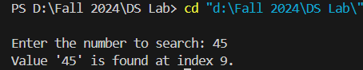

**Task 2:** Implement Linear Search for an array with character data using recursive method.

**Solution:**

#include <stdio.h>

int  linearSearchCharacter(char A[], char value, int i, int size) {

    if (i >= size) {

        return -1;

    }

    else if (A[i] == value) {

        return i;

    }

    return  linearSearchCharacter(A, value, i + 1, size);

}

int main() {

    char A[] = {'a', 's', 'h', 'b', 'd', 'u', 'i', 'n'};

    char value;

    int size = sizeof(A) / sizeof(A[0]);

    printf("\nEnter the character to search: ");

    scanf(" %c", &value);

    int result = linearSearchCharacter(A, value, 0, size);

    if (result == -1) {

        printf("Character '%c' is not found in the array.\n", value);

    } else {

        printf("Character '%c' is found at index %d.\n", value, result);

    }

    return 0;

}

**Output:**

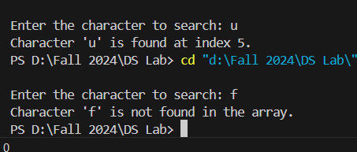

**Task 3:** Implement Binary Search for an array with character data using recursive method.

**Solution:**

#include <stdio.h>

int binarySearchCharacter(char A[], char value, int L, int R) {

    if (L > R) {

        return -1;

    }

    int middle = L + (R - L) / 2;

    if (A[middle] == value) {

        return middle;

    }

    else if (A[middle] > value) {

        return binarySearchCharacter(A, value, L, middle - 1);

    }

    else{

    return binarySearchCharacter(A, value, middle + 1, R);

    }

}

int main() {

    char A[] = {'a', 'b', 'e', 'i', 'm', 'p', 'x', 'z'};

    char value;

    int size ;

        size = sizeof(A) / sizeof(A[0]);

    printf("\nEnter the character to search: ");

    scanf("%c", &value);

    int i=0;

    int result = binarySearchCharacter(A, value, i, size - 1);

    if (result == -1) {

        printf("Character '%c' is not found in the array.\n", value);

    } else {

        printf("Character '%c' is found at index %d.\n", value, result);

    }

    return 0;

}

**Output:**

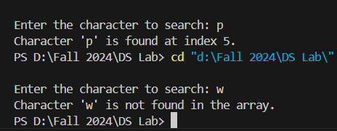

**4. DISCUSSION**

In this lab report, we explored how to find elements in an array using recursion. We tackled three main problems. First, we used recursion with linear search to find a number in an array. Second, we applied the same approach to search for a character in a string. Lastly, we implemented binary search, which efficiently narrows down the search area by half with each step, making it ideal for sorted arrays or strings.